1a Delverable
Deliverable
Screenshot of: RDS SG inbound rule using source = sg-ec2-lab EC2 role attached /list output showing at least 3 notes

Inspect a specific security group (inbound & outbound rules)

aws ec2 describe-security-groups \
--group-ids sg-0f4afde3b9c95cd61 \
--region us-east-2 \
--output json

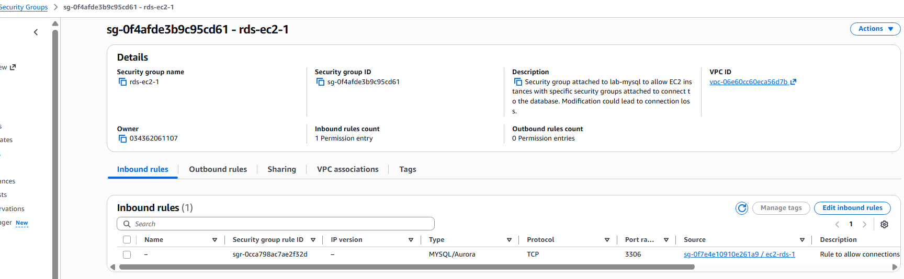

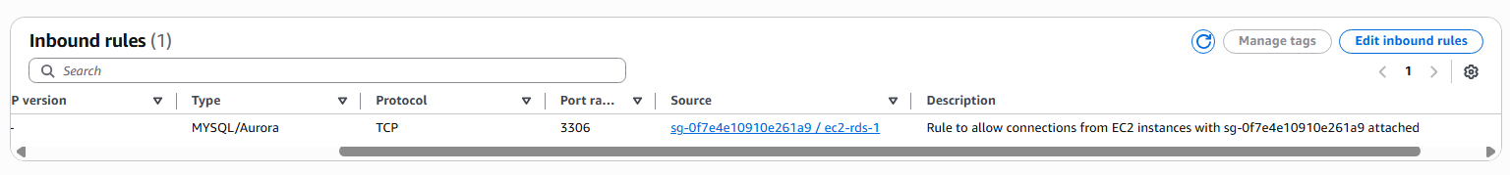

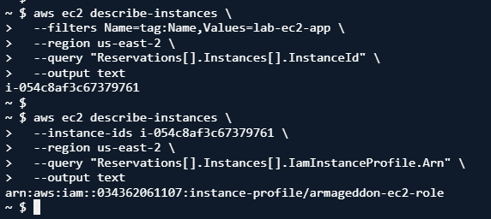

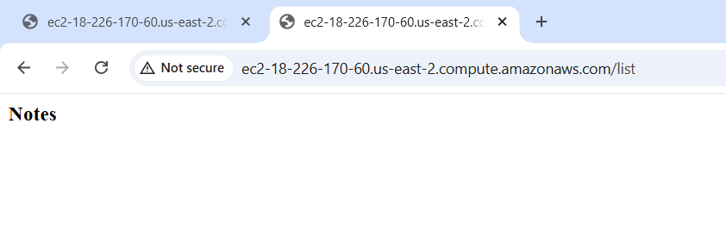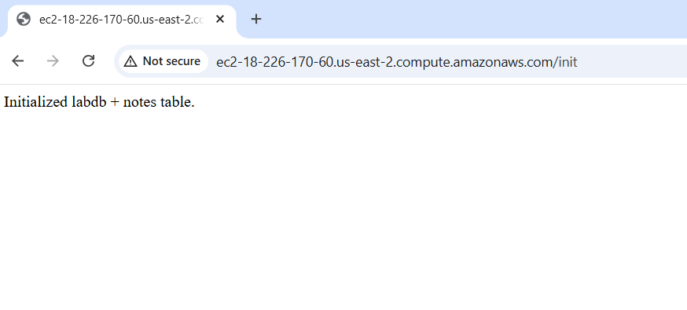

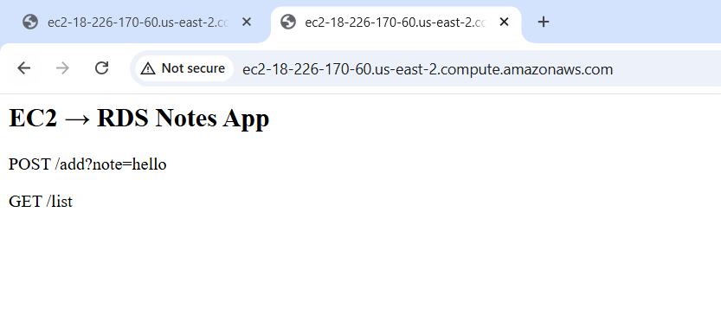

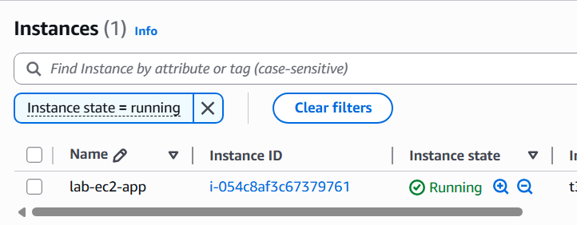

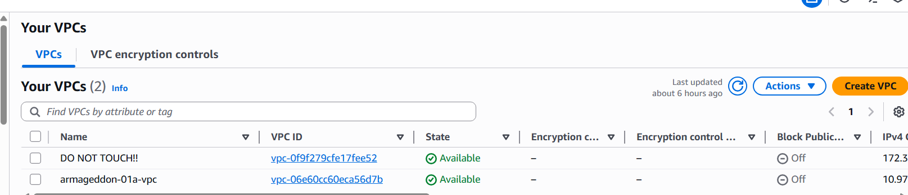

Short answers: A) Why is DB inbound source restricted to the EC2 security group?
-It ensures that the database is not exposed to the public internet.
B) What port does MySQL use?
-It uses port 3306
C) Why is Secrets Manager better than storing creds in code/user-data?
-Secrets Manager provides secure access control through IAM. Also, SM encrypts the secrets.

Evidence for Audits / Labs (Recommended Output)

aws ec2 describe-security-groups --group-ids sg-0123456789abcdef0 > sg.json aws rds describe-db-instances --db-instance-identifier mydb01 > rds.json aws secretsmanager describe-secret --secret-id my-db-secret > secret.json aws ec2 describe-instances --instance-ids i-0123456789abcdef0 > instance.json aws iam list-attached-role-policies --role-name MyEC2Role > role-policies.json

aws ec2 describe-security-groups --group-ids sg-0123456789abcdef0 > sg.json aws rds describe-db-instances --db-instance-identifier mydb01 > rds.json aws secretsmanager describe-secret --secret-id my-db-secret > secret.json aws ec2 describe-instances --instance-ids i-0123456789abcdef0 > instance.json aws iam list-attached-role-policies --role-name MyEC2Role > role-policies.json

Then Answer:
1. Why each rule exists?
-Allows EC2 instance to connect to the RDS database (MySQL) through port 3306.
2. What would break if removed?
-This is due to dependencies. Without inbound port 3306 from the EC2 sg the application/app server cannot connect to the database and read it. Also, a removal can prevent the
EC2 from reaching the Secrets.
3. Why broader access is forbidden?
-Due to rule of least privilege. This allows only network traffic from the specified resources to be in place.
4. Why this role exists?
This allows the EC2 to read a secret from the Secrets Manager
5. Why it can read this secret?
-The IAM policy is attached to the role.
6. Why it cannot read others?
-IAM policies are for specific resources and not all or other resources.

